[Blank page only required for Bachelor's and Master's theses].
[For bachelor and master theses: Please sign this first page]
[Please delete comment and, if applicable, blank page]

______________________ _____________________
Place, Date Signature



University of Hamburg Business School
Seminar paper / Bachelor thesis / Master thesis
at the Chair for Digital Transformation in Retail

Prof. Dr. Theresa Bockelmann

[Title]

Name: | [Vorname] [Nachname] |  | Matriculation number: | [Matriculation number]
E-Mail: | [E-Mail-Adresse]
Address: | [Street] [Number], [Zip Code] [Place] |  | Course of study: | [B.Sc./M.Sc.]  [Course of study]
 |  |  | Semester: | [Semester]
Telefon: | [Telephone number] |  | Submission Date: | [DD].[MM.].[JJJJ]

I. Table of Contents

II. Table of Figures ii
III. List of Tables iii
V. List of Abbreviations iv
VI. List of Symbols v
1. Title Chapter I 1
2. Title Chapter II 1
2.1 Title Subsection 1
2.1.1 Title Subsection 2
2.1.2 Title Subsection 3
2.2 Title Subsection 4
3. Citation Rules 5
4. Title Chapter IV 6
VII. Appendix vii
VIII. List of References viii
IX. Affidavit ix

II. Table of Figures

Figure 1: [Titel der Graphic] 2

III. List of Tables

Table 1: [Titel of table] 3

V. List of Abbreviations

Abbreviation | Explanation
[Abbreviation 1] | [Explanation abbreviation 1]
[Abbreviation 2] | [Explanation abbreviation 2]

VI. List of Symbols

Symbol | Explanation
[Symbol 1] | [Explanation symbol 1]
[Symbol 2] | [Explanation symbol 2]

1. Title Chapter I
[Text]

2. Title Chapter II
[Text]

2.1 Title Subsection
[Text]

2.1.1 Title Subsection
[Text]
Figure 1: [Titel der Graphic]
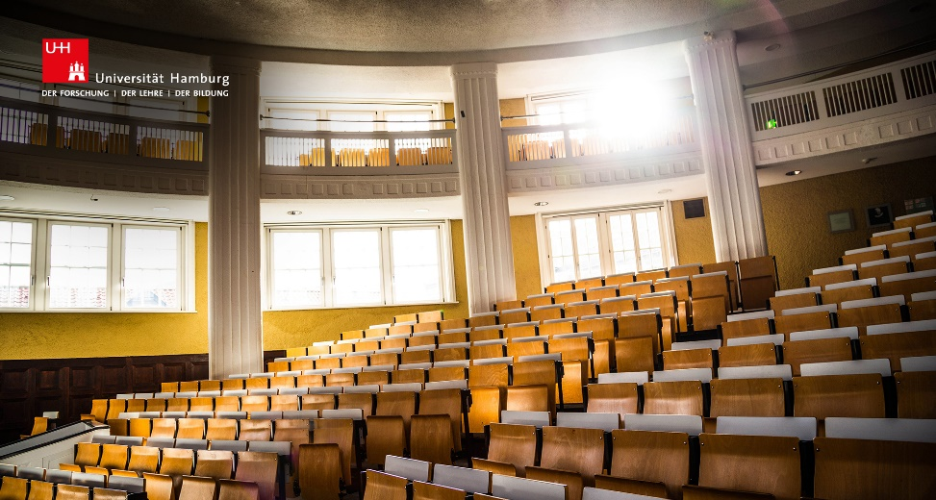
Source: [insert source]

Note on inserting graphics:
To update the list of figures, please right-click on the list of figures on page ii and select Update Fields / Update Entire List.

2.1.2 Title Subsection
[Text]
Table 1: [Titel of table]
 | Column 1 | Column 2 | Column 3
Row 1
Row 2
Source: [insert source]

Note on inserting tables:
To update the table directory, please right-click on the list of tables on page iii and select Update fields / Update entire directory.

2.2 Title Subsection
[Text]

3. Citation Rules
Please use the source references in the body text for your papers according to APA guidelines:
- Reference in the text is directly after the quotation or paraphrase (before the punctuation mark)
Examples:
Direct citation:
- „A consistent citation style is important“ (Müller, 2019, p. 23).
- Müller (2019, p. 23) emphasizes: „A consistent citation style is important.“
Indirect citation:
- A study comparing X and Y shows that ... (Müller, 2019).
- The study by Müller (2019) shows that......
Special cases:
 | Reference
No author | („Title of the source“, year)
Two authors | (Müller & Meyer, year)
Three or more authors | (Müller et al., year)
Organisation | (Microsoft, year)
Organisation – abbreviation | (WHO, year)

4. Title Chapter IV

VII. Appendix

VIII. List of References
Please use the APA guidelines for your bibliography: Author (year). Title.
Müller, T. (2022). How to write a Thesis.
Special features by type of source:
- Book: Author (year). Title (ed.). Place: Publisher.
- Chapter from anthology: Author. (year). Title of the chapter. Editor (Ed.), Title of the anthology (if applicable, edition, page area). Place: Publisher.
- Journal Paper: Author. (year). Article. Journa, Volume(Issue number), page area, if applicable DOI or URL
- Internet source: Author. (year, Day.Month). Article. Name of the website. If applicable retrieval date, URL

IX. Affidavit

I affirm under oath that I have carried out the above work independently and without outside help and have not used any aids other than those given in the attached list.
All passages taken verbatim or analogously from publications are marked as such. All internet sources are attached to the work. Furthermore, I assure that I have not previously submitted the thesis in another examination procedure and that the submitted written version corresponds to the one on the electronic storage medium.
I agree that my thesis will be checked by the staff of the Chair of Information Systems and Digital Innovation of Prof. Dr. Jan Christof Recker using the plagiarism software Turnitin.

__________________________________________________
Place, Date, Signature

