<Exposé / Bachelor Thesis/ Master Thesis>
<Title>

submitted by
<Titus Template>

Faculty: | …
[eventually Department] | […]
Study Program: | …
Matriculation Number: | …
Supervisor: | …
First Reviewer: | <Prof. Dr. Stefan Voß>
 | Institute of Information Systems
Second Reviewer: | …
 | …

Table of Contents
Table of Contents 1
List of Figures (Example) 2
List of Tables (Example) 3
List of Abbreviations (Example) 4
List of Symbols (Example) 5
1 General Hints on Writing an Exposé 6
1.1 Problem Description and Differentiation 6
1.2 Objective 6
1.3 Investigative Approach 6
1.4 Outline 7
1.5 Literature 7
1.6 Schedule 7
2 Appendices 8
2.1 Appendix A: Examples for Text Formatting: Continuous Text, Bullet Points, Enumerations, Tables 8
2.2 Appendix B: Chapter of the Second Hierarchy Level 10
2.2.1 Subchapter of the Third Hierarchy Level 10
2.2.1.1 Subchapter of the Fourth Hierarchy Level: long chapter headline, which exceeds several lines, also in the table of contents 10
2.2.1.1.1 Subchapter of the Fifth Hierarchy Level: long chapter headline, which exceeds several lines, also in the table of contents 10
2.3 Appendix C: Figures (Example) 10
2.4 References (Example) 11
2.5 Affidavit (not included in the Exposé) 12

List of Figures (Example)
Figure 1: NFC operating modes (Finkenzeller, 2010, p. 58) 3

List of Tables (Example)
Table 1: key characteristics of cloud computing (Armbrust et al., 2010) 2
Table 2: another table layout 4

List of Abbreviations (Example)
ADR American Depositary Receipt
BAU Business As Usual
CKM Customer Knowledge Management
dpi dots per inch
ERP Enterprise Resource Planning
GVC Global Value Chain
LIFO Last In, First Out
SCM Supply Chain Management

List of Symbols (Example)
C capital value
d_{t} demand in period t
i interest rate
du duration of usage

General Hints on Writing an Exposé
Chapter 1 with its subsections refer only to the preparation of an exposé. For information on preparing and formatting a Bachelor's or Master's thesis, please consult our "Recommendations for the formal design of scientific papers" (cf. IWI Hamburg, 2026).
The purpose of a scientific paper is to gain and disseminate knowledge based on the current state-of-the-art. For the planning of such a work, an exposé is prepared. The exposé is addressed to third parties and should give readers an impression of the planned project. Content and formal requirements are derived from the "Recommendations for the formal design of scientific papers" (cf. IWI Hamburg, 2026). The following sections should be included in the synopsis, especially in the context of a Bachelor’s and Master´s thesis.

Problem Description and Differentiation
First, an overview of the topic and the derived problem is given. For this purpose, it is necessary to analyze the current state of research based on the relevant literature. An extensive literature search is the prerequisite (taking into account the references given on the topic). A preliminary discussion with the supervisor is recommended. The aim of this section is to establish a general reference to superordinate topics, to derive and classify a problem. Additionally, the problem definition should clarify which aspects have already been dealt with and which aspects have not yet been dealt with. Furthermore, the problem should undergo a sufficient Differentiation from other subtopics. This section is mainly devoted to the current state of knowledge in research and practice.

Objective
The second step is to describe a precise objective of the work. For this purpose, the central subject and the focal points of the planned work must be defined and justified. The relevant literature often discusses open questions. In this section the reader should learn which aspects of the problem will be investigated under which restrictions. Thus, it is devoted to the central question of the extent to which the work should contribute to gaining new knowledge for research and practice. The aim is to formulate an objective as concise and as problem-oriented as possible.

Investigative Approach
This section describes the theoretical and methodological approach planned to develop and elaborate the problem, as well as to achieve the objective. The deployment of materials and tools that will be used for the investigation (e.g. empirical data, software tools, etc.) should also be mentioned in this section.

Outline
A consistent and self-contained line of thought is also reflected in a balanced outline with appropriate bullet points (cf. "Recommendations for the formal design of scientific papers", IWI Hamburg, 2020). This section should contain the planned outline of the thesis, indicating the planned scope per chapter. We strongly recommend to present the draft of the outline to the thesis supervisor.

Literature
For the exposé, a part of the literature research should have been carried out already. The literature used up to this point is to be included. You do not need to reference your sources within the text of the exposé. The overview of the literature should, however, contain the (basic) sources on the subject matter

Schedule
On the one hand, a timetable can clarify the feasibility of your research project; on the other hand, it documents the structure of your work. To this end, you should include a preliminary schedule in this section. The most relevant subject matter of the schedule are the important milestones. Especially for larger projects a schedule is of utmost importance.

Appendices

Appendix A: Examples for Text Formatting: Continuous Text, Bullet Points, Enumerations, Tables
Meanwhile, information technology (IT) has become essential to exchange information etween involved inter-organizational actors and across global supply chains more efficiently.
- Providers of port infrastructure and facilities
- Providers of cargo handling services
- Maritime transport operators
- Inland transport operators
- Representatives of cargo
Nam lacus libero, pretium at, lobortis vitae, ultricies et, tellus. Donec aliquet, tortor sed accumsan bibendum, erat ligula aliquet magna, vitae ornare odio metus a mi. Morbi ac orci et nisl hendrerit mollis. Suspendisse ut massa. Cras nec ante. Pellentesque a nulla. Cum sociis natoque penatibus et magnis dis parturient montes, nascetur ridiculus mus. Aliquam tincidunt urna. Nulla ullamcorper vestibulum turpis. Pellentesque cursus luctus mauris. Nam dui ligula, fringilla a, euismod sodales, sollicitudin vel, wisi. Morbi auctor lorem non justo. Nam lacus libero, pretium at, lobortis vitae, ultricies et, tellus. Donec aliquet, tortor sed accumsan bibendum, erat ligula aliquet magna, vitae ornare odio metus a mi. Morbi ac orci et nisl hendrerit mollis. Suspendisse ut massa. Cras nec ante. Pellentesque a nulla.
- Providers of port infrastructure and facilities
- Providers of cargo handling services
- Maritime transport operators
- Inland transport operators
- Representatives of cargo.
Cum sociis natoque penatibus et magnis dis parturient montes, nascetur ridiculus mus. Aliquam tincidunt urna. Nulla ullamcorper vestibulum turpis. Pellentesque cursus luctus mauris. Nam dui ligula, fringilla a, euismod sodales, sollicitudin vel, wisi. Morbi auctor lorem non justo. Nam lacus libero, pretium at, lobortis vitae, ultricies et, tellus. Donec aliquet, tortor sed accumsan bibendum, erat ligula aliquet magna, vitae ornare odio metus a mi. Morbi ac orci et nisl hendrerit mollis. Suspendisse ut massa. Cras nec ante. Pellentesque a nulla. Cum sociis natoque penatibus et magnis dis parturient montes, nascetur ridiculus mus. Aliquam tincidunt urna. Nulla ullamcorper vestibulum turpis. Pellentesque cursus luctus mauris. Cum sociis natoque penatibus et magnis dis parturient montes, nascetur ridiculus mus. Aliquam tincidunt urna. Nulla ullamcorper vestibulum turpis. Pellentesque cursus luctus mauris. Nam dui ligula, fringilla a, euismod sodales, sollicitudin vel, wisi. Morbi auctor lorem non justo. Nam lacus libero, pretium at, lobortis vitae, ultricies et, tellus. Donec aliquet, tortor sed accumsan bibendum, erat ligula aliquet magna, vitae ornare odio metus a mi. Morbi ac orci et nisl hendrerit mollis. Suspendisse ut massa. Cras nec ante. Pellentesque a nulla. Cum sociis natoque penatibus et magnis dis parturient montes, nascetur ridiculus mus. Aliquam tincidunt urna. Nulla ullamcorper vestibulum turpis. Pellentesque cursus luctus mauris. Cum sociis natoque penatibus et magnis dis parturient montes, nascetur ridiculus mus. Aliquam tincidunt urna. Nulla ullamcorper vestibulum turpis. Pellentesque cursus luctus mauris. Nam dui ligula, fringilla a, euismod sodales, sollicitudin vel, wisi. Morbi auctor lorem non justo. Nam lacus libero, pretium at, lobortis vitae, ultricies et, tellus. Donec aliquet, tortor sed accumsan bibendum, erat ligula aliquet magna, vitae ornare odio metus a mi. Morbi ac orci et nisl hendrerit mollis. Suspendisse ut massa. Cras nec ante. Pellentesque a nulla. Cum sociis natoque penatibus et magnis dis parturient montes, nascetur ridiculus mus. Aliquam tincidunt urna. Nulla ullamcorper vestibulum turpis. Pellentesque cursus luctus mauris.

On-demand  self-service | Lorem ipsum dolor sit amet, consectetuer adipiscing elit. Ut purus elit, vestibulum ut, placerat ac, adipiscing vitae, felis. Curabitur dictum gravida mauris. Nam arcu libero, nonummy eget, consectetuer id, vulputate a, magna. Donec vehicular augue eu neque. Pellentesque habitant morbi tristique senectus et netus et malesuada fames ac turpis egestas. Mauris ut leo. Cras viverra metus rhoncus sem. Nulla et lectus vestibulum urna fringilla ultrices. Phasellus eu tellus sit amet tortor gravida placerat. Integer sapien est, iaculis in, pretium quis, viverra ac,  nunc. Praesent eget sem vel leo ultrices bibendum. Aenean faucibus. Morbi dolor nulla, malesuada eu, pulvinar at, mollis ac, nulla. Curabitur auctor semper nulla. Donec varius orci eget risus. Duis nibh mi, congue eu, accumsan eleifend, sagittis quis, diam. Duis eget orci sit amet orci
Elasticity  and scalability | Lorem ipsum dolor sit amet, consectetuer adipiscing elit. Ut purus elit, vestibulum ut, placerat ac, adipiscing vitae, felis. Curabitur dictum gravida mauris. Nam arcu libero, nonummy eget, consectetuer id, vulputate a, magna. Donec vehicular augue eu neque. Pellentesque habitant morbi tristique senectus et netus et malesuada fames ac turpis egestas. Mauris ut leo. Cras viverra metus rhoncus sem. Nulla et lectus vestibulum urna fringilla ultrices. Phasellus eu tellus sit amet tortor gravida placerat. Integer sapien est, iaculis in, pretium quis, viverra ac, nunc. Praesent eget sem vel leo ultrices bibendum.
Table 1: key characteristics of cloud computing (Armbrust et al., 2010)

Color | Form | No.
red | rectangle | 100
blue | circle | 99
yellow | triangle | 98
Table 2: another table layout

Appendix B: Chapter of the Second Hierarchy Level

Subchapter of the Third Hierarchy Level

Subchapter of the Fourth Hierarchy Level: long chapter headline, which exceeds several lines, also in the table of contents

Subchapter of the Fifth Hierarchy Level: long chapter headline, which exceeds several lines, also in the table of contents

Appendix C: Figures (Example)
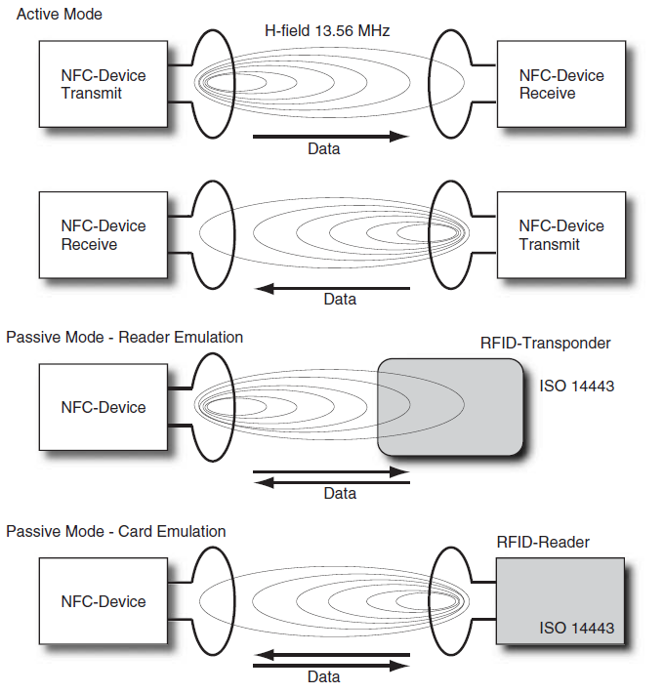
Figure 1: NFC operating modes (Finkenzeller, 2010, p. 58)

References (Example)
IWI Hamburg (2026). Empfehlungen für formale Gestaltung wissenschaftlicher Arbeiten.
URL: https://www.bwl.uni-hamburg.de/iwi/studium/abschlussarbeiten.html
Böse, J., T. Reiners, D. Steenken, S. Voß (2000). Vehicle dispatching at seaport container terminals using evolutionary algorithms. In Proceedings of the 33rd Annual Hawaii International Conference on System Sciences (HICSS). IEEE, Maui, HI, USA, 1–10, DOI: 10.1109/HICSS.2000.926669
Davenport, T. H., D. J. Patil (2012). Data scientist: The sexiest job of the 21st century. https://hbr.org/2012/10/data-scientist-the-sexiest-job-of-the-21st-century. last access: 23.04.2026
Fink, A., G. Schneidereit, S. Voß (2005). Grundlagen der Wirtschaftsinformatik (2. Aufl.). Physica, Heidelberg. DOI: 10.1007/3-7908-1635-3
Heilig, L., S. Voß (2014). A scientometric analysis of cloud computing literature. IEEE Transactions on Cloud Computing 2(3), 266–278. DOI: 10.1109/TCC.2014.2321168
Heilig, L., S. Voß (2017). Inter-terminal transportation: An annotated bibliography and research agenda. Flexible Services and Manufacturing Journal 29, 35-63, Springer. DOI: 10.1007/s10696-016-9237-7
Jacobs, A. (2009). The pathologies of big data. Communications of the ACM 52(8), 36–44. DOI: 10.1145/1536616.1536632
Rechenberg, I. (1964). Kybernetische Lösungsansteuerung einer experimentellen Forschungsaufgabe. In Annual Conference of the WGLR. 1–10.
Ropke, S. (2005). Heuristic and exact algorithms for vehicle routing problems. Ph. D. thesis, University of Copenhagen. https://backend.orbit.dtu.dk/ws/portalfiles/portal/3155278/Heuristic%20and%20exact%20algorithms%20for%20vehicle%20routing%20problems_Ropke.pdf last access: 23.04.2026
Taillard, E. D., S. Voß (2002). POPMUSIC – Partial Optimization Metaheuristic under Special Intensification Conditions. In Celso C. Ribeiro, Pierre Hansen (Hrsg.), Essays and Surveys in Metaheuristics, 613–629. Kluwer, New York, USA. DOI: 10.1007/978-1-4615-1507-4_27

Affidavit (not included in the Exposé)
I hereby declare that I wrote this thesis in my study program Information Systems on my own and without the help of any third party or the use of any other than the cited sources and tools. I also confirm that all texts that I copied directly or in their sense are marked and cited as such. Additionally, I confirm that I did and do not submit this thesis to any other examination board and that the paper version of this thesis is an exact copy of the electronic version that I have handed in.

Hamburg, date ____________________ Signature:___________________________

